## 1 Codec IP Source Frame Requirement in Sirius

### 1.0 Codec IPS

Codec IPs includes H264/HEVC/JPEG Codec and Display .

### 1.1 Endian Mode

Little Endian Mode

Eg: 128bit Little Endian

Mem[ADDR] = 0xFFEEDDCCBBAA99887766554433221100

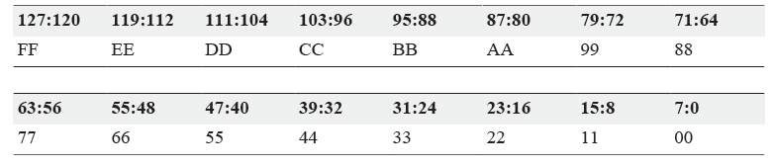

### 1.2 Pixel Format

#### 1.2.1 Packing Formats

8bit mode : 1pixel/per byte

10bit mode: 1pixel/2 bytes

// (需要支持下图中的1和2mode, 2 是给cf50 和 display scalling/mirror/rotation用的，1是给jpeg用的)

3pixel/4 bytes // (LSB， 同下面的mode 4)

12bit mode: 1pixel/2 bytes (同10bit 1pixel/2byte 中的mode 1.)

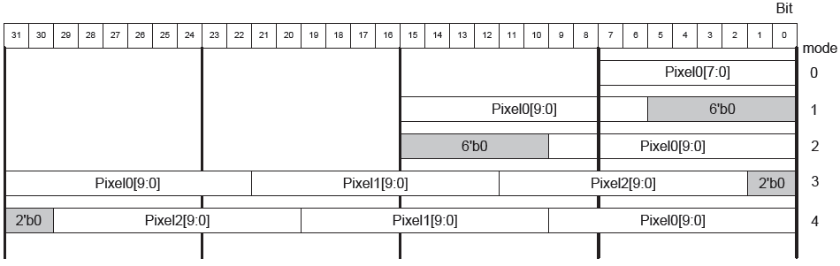

#### 1.2.2 Pixel Order in 128Bits

8bit mode:

两种摆放方式

CF50: 需要大端摆放

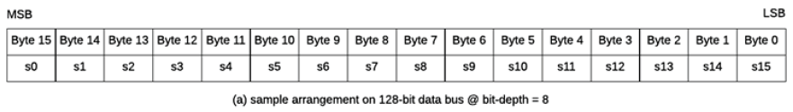

HEVC/H264/JPEG/Display: 小端摆放即可

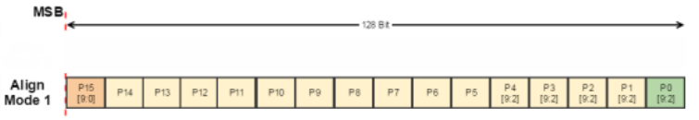

10bit mode:

1pixel/2byte, CF50, JPEG, display scaling/rotation/mirror

CF50 need mode 0

JPEG/Display scalling/rotation/mirror need mode 1



3pixel/4 bytes, HEVC, Display without scalling / rotaton / mirror

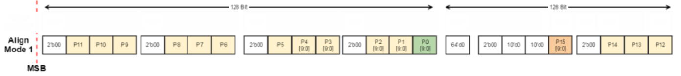

### 1.3 YUV Frame Format

8bit mode:

Planar mode

10bit mode

Planar Mode

Cb/Cr Interleave mode ： Only for display with scaling / mirror/ rotation

Note: Refer to 1.5 chapter

### 1.4 YUV Down sampling(4:4:4 -> 4:2:2 -> 4:2:0)

#### 1.4.1 YUV4:4:4

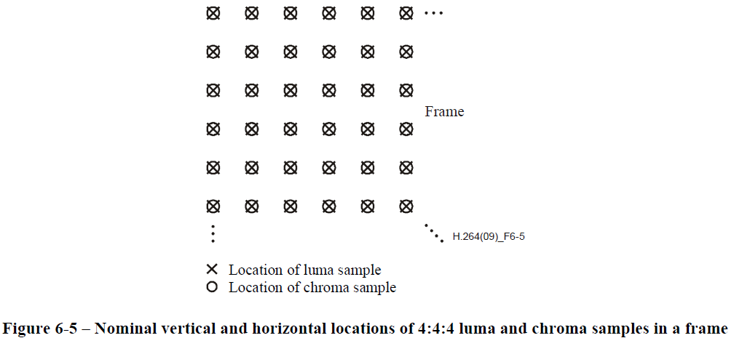

#### 1.4.2 YUV4:2:2

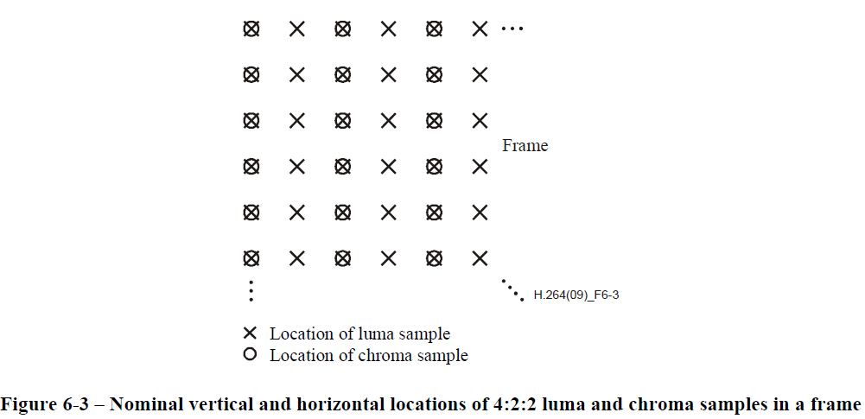

#### 1.4.3 YUV4:2:0

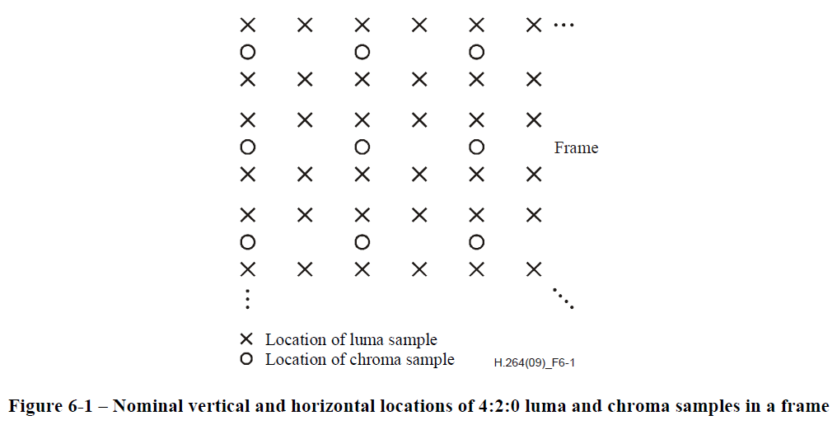

JPEG can support other 4:2:0 sampling format as below figure .

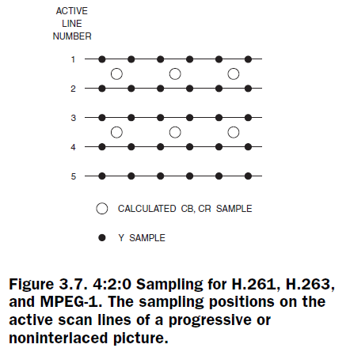

#### 1.4.4 sampling in Top and Bottom Fields

##### 1.4.4.1 4:2:0 Top and Bottom Fields sampling

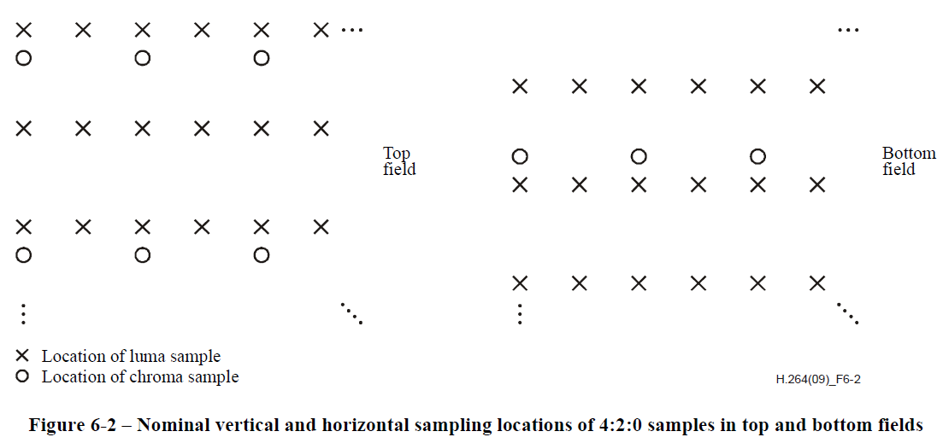

##### 1.4.4.2 4:2:2 Top and Bottom Fields sampling

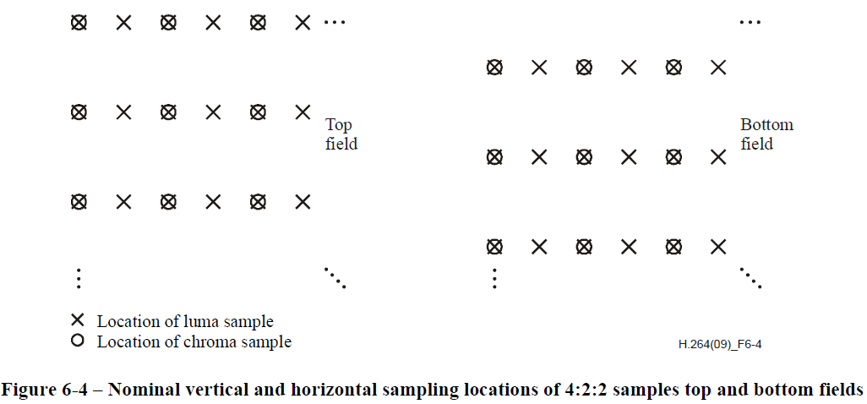

##### 1.4.4.3 4:4:4 Top and Bottom Fields sampling

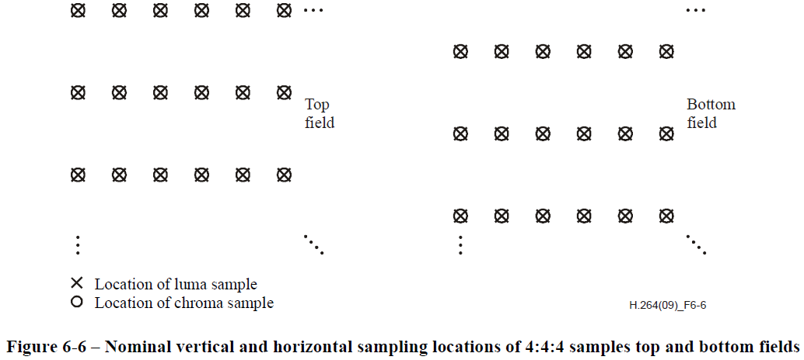

### 1.5 HEVC YUV Data Format in DDR

#### 1.5.1 Planar Mode Mapping



Note:

1> Y/Cb/Cr Base Addr is configurable by register

2> Luma/Chroma Stride is configurable by register

3> Cb_Height = (Sampling mode == 4:2:2 ? Height : Height/2 ); //Cr_Height = Cb_Height

#### 1.5.2 Cb/Cr Interleave Mode Mapping



Note:

1> Y/Cb/Cr Base Addr is configurable by register

2> Luma/Chroma Stride is configurable by register

3> Cb_Height = (Sampling mode == 4:2:2 ? Height : Height/2 ); //Cr_Height = Cb_Height

### 1.6 RGB2YUV

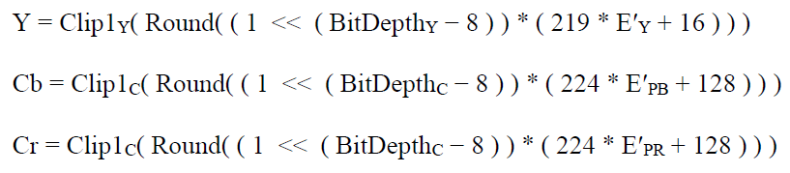

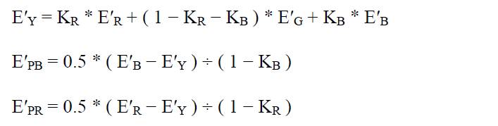

Where E’Y,E’R, E’G, E’B are real numbers with values in the range of 0 to 1 inclusive ([0,1]), and E’PB and E’PR are in the range of -0.5 to 0.5 inclusive([-0.5,0.5]).

The variable KR, KB is configurable by register . The value of KR, KB isdifferent by selecting BT.601/BT.709/BT.2020 or other standards .

|  |  |  |  |  |
| --- | --- | --- | --- | --- |
| Standard  Variable | BT.601-6 | BT.709-5 | BT.2020 | Others |
| KR | 0.299 | 0.2126 | 0.2627 | User Define |
| KB | 0.114 | 0.0722 | 0.0593 | User Define |

### 1.7 Optional Feature

⑴ Sampling mode 4:0:0

⑵ Big Endian mode

⑶ 4:2:2 Packed Frame format

⑷ Sampling mode 4:4:0 (jpeg)

⑸

⑹